

Project Development Phase Delivery of Sprint-4

|  |  |
| --- | --- |
| **Date** | 11.11.2022 |
| **Team Id** | PNT2022TMID33764 |
| **Project Name** | AI Based Discourse for Banking Industry |

General Query Action

Procedure to know the Mail Id and Helpline Number of the Bank:

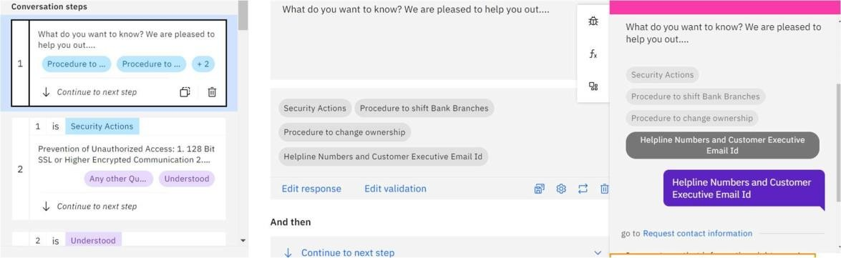

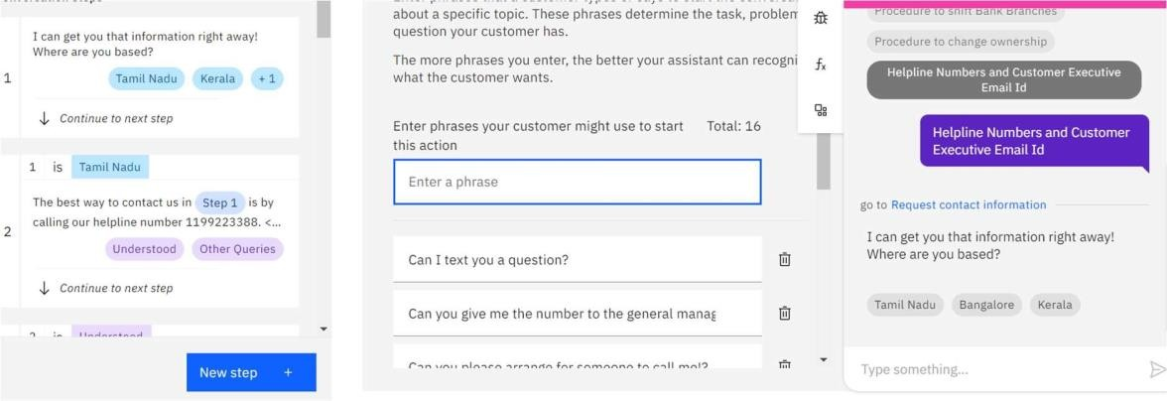



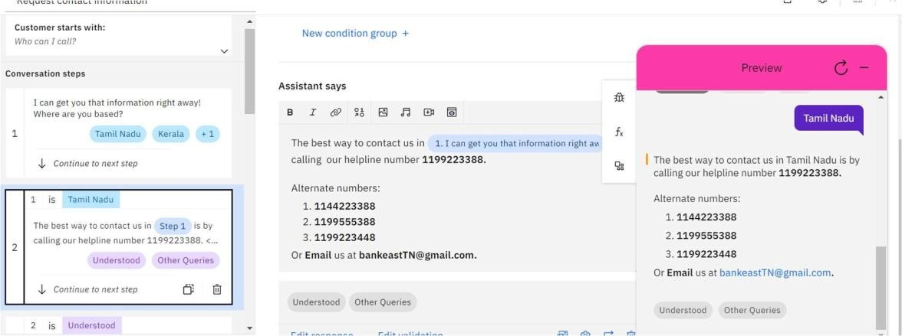

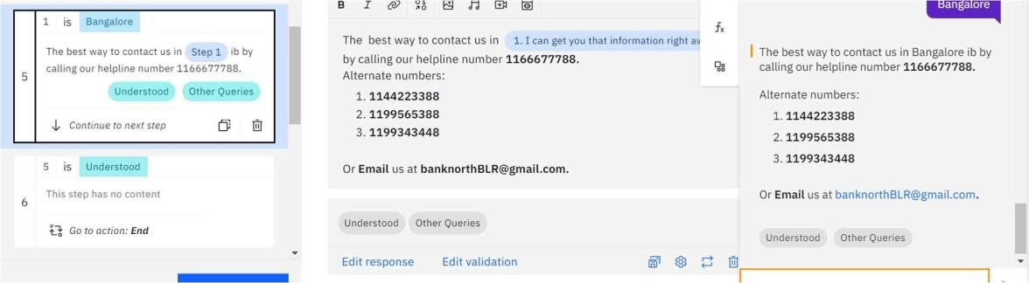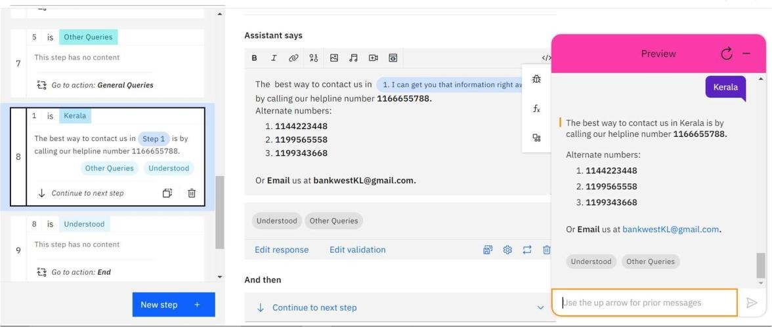



Procedure to Change Ownership:

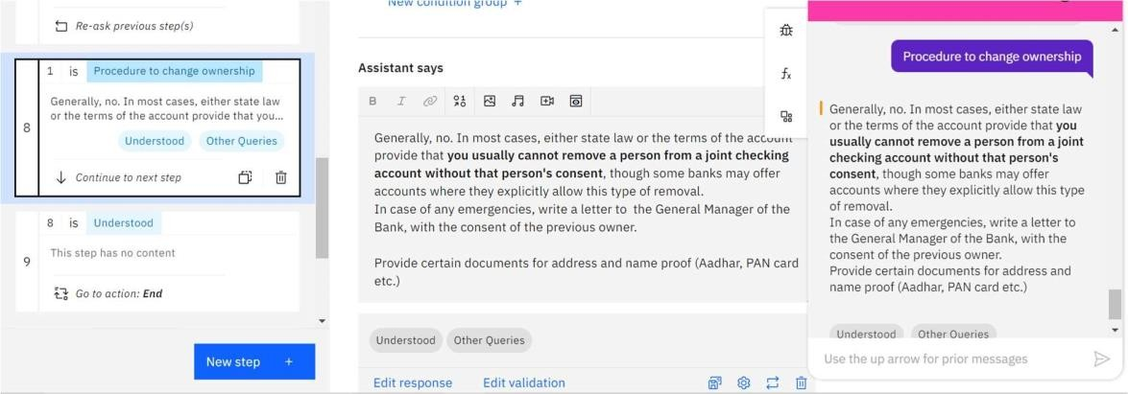

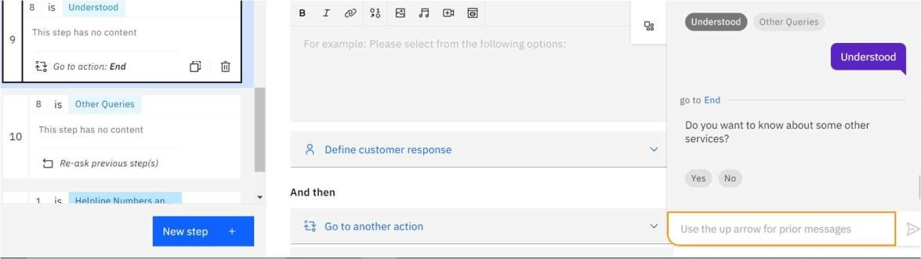

Net banking Action Procedure to check the balance from the bank:

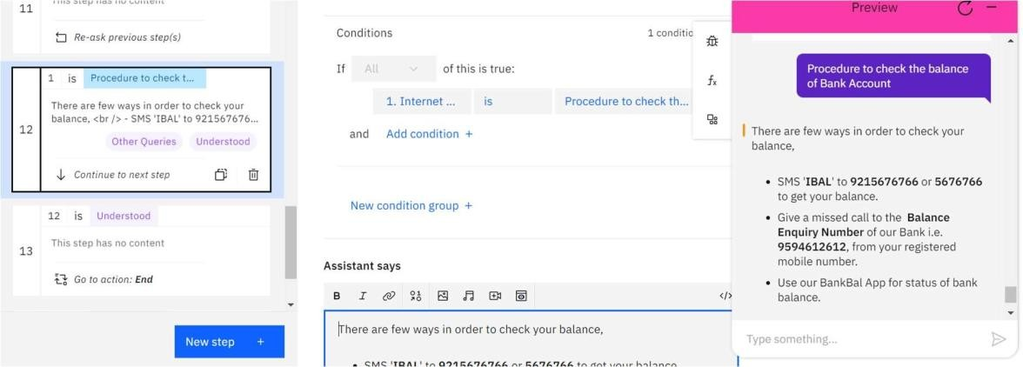



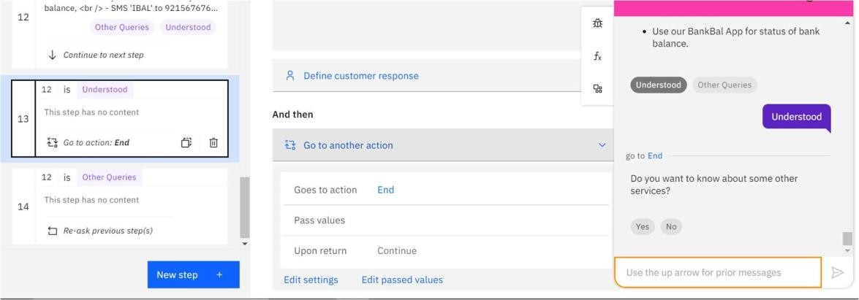

Current Account Action

